Ahmed Ehab Ahmed
MongoDB Lab2

1- run following queries:
a- Display all documents in instructors collection
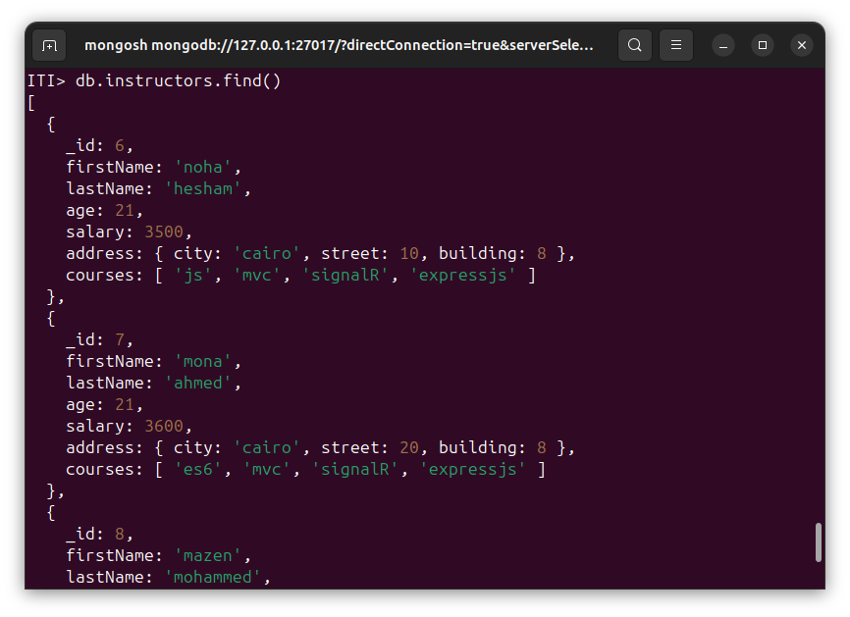
b- Display all instructors with salaries greater than 4000 (only show firstName and salary)
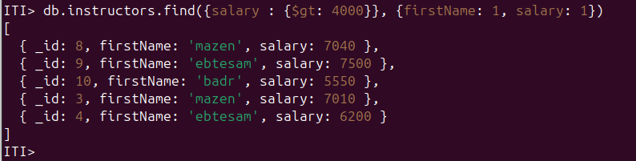
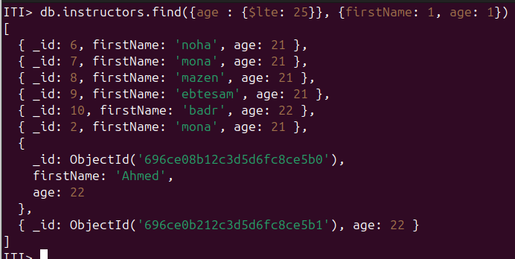
c- Display all instructors with ages less than or equal 25.
d- Display all instructors with city mansoura and sreet number 10 or 14 only display (firstname,address,salary).
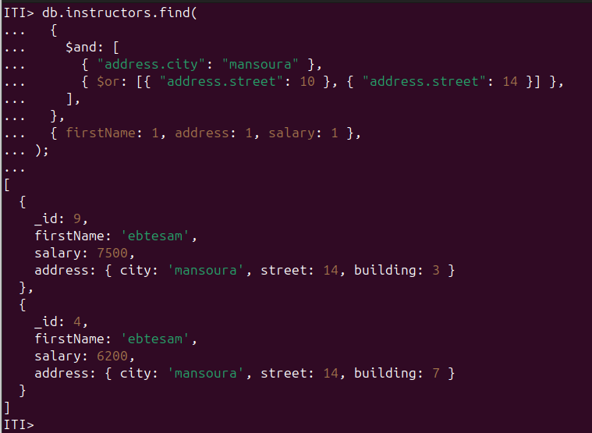
e- Display all instructors that have js and jquery in their courses (both of them not one of them).
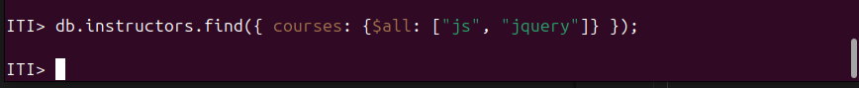
f- Display number of courses for each instructor and display first name with number of courses.
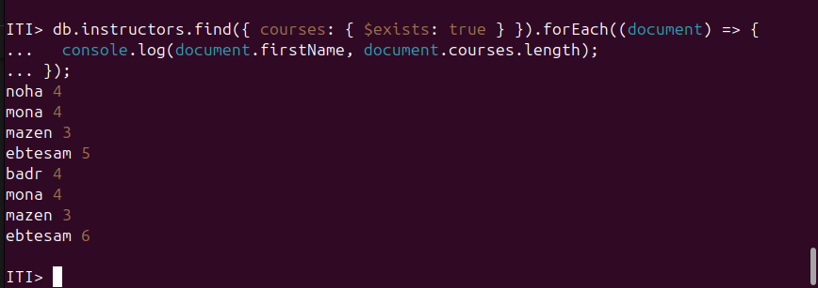
g- Write mongodb query to get all instructors that have firstName and lastName properties , sort them by firstName ascending then by lastName descending and finally display their data FullName and age Note: use mongoDB sort function
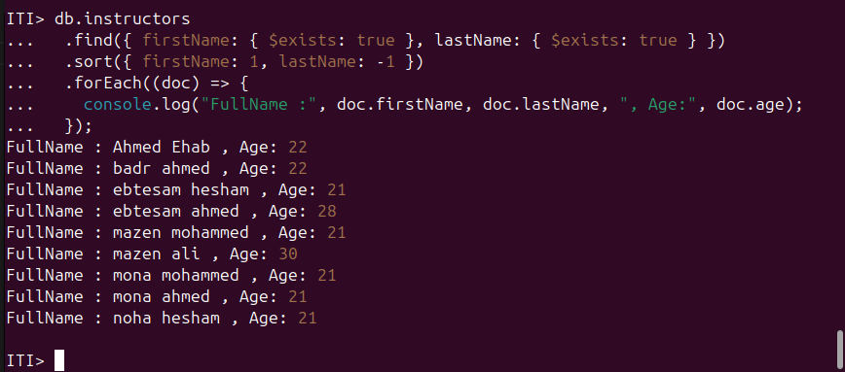
h- Delete instructor with first name “ebtesam” and has only 5 courses in courses array
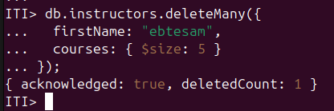
i- Add active property to all instructors and set its value to true.
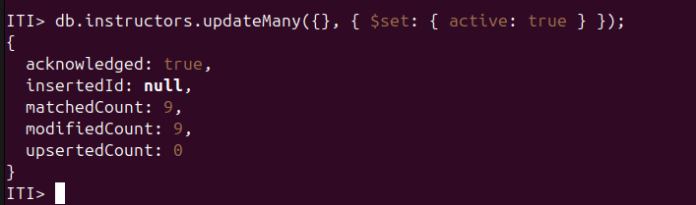
j- Change “EF” course to “jquery” for “mazen mohammed” instructor (without knowing EF Index in courses array)
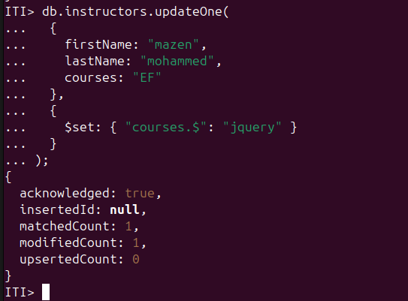
k- Add jquery course for “noha hesham”.
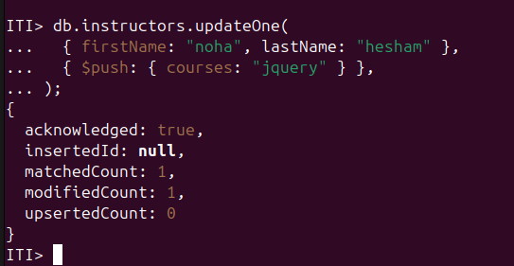
l- Remove courses property for “ahmed mohammed ” instructor
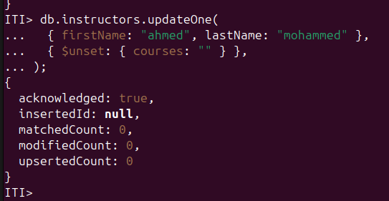
m- Decrease salary by 500 for all instructors that has only 3 courses in their list ($inc)
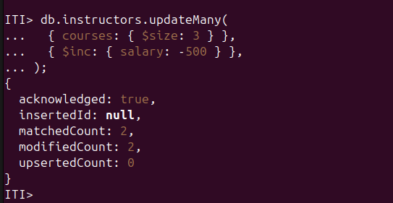
n- Rename address field for all instructors to fullAddress.
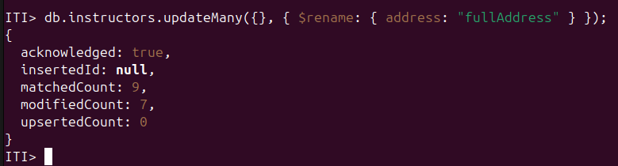
o- Change street number for noha hesham to 20
